[2nd June, 2025] P & V Assurances (EOP) Post Internal Sync Notes Template
Customer was handed over to me by Ahmed Elfouly with note : Regular cadence

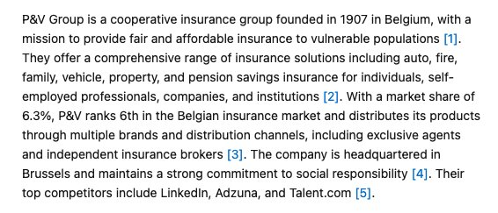

PUT IN EMEA CUSTOMER FOLDER
Account Team Below:

AM: jshailj@
Concierge agent: NA
SA: akirmak@

During the internal sync call, you should drive the conversation; use the following questions and document them in the customer quip folder:
- Why did the customer choose EOP + What are the previous support plans before EOP?
  - For 1 year EOP
  - Shailesh (AM) has been with the account for just 4 months now - no details as such
  - No account plan for this customer - Customer had mentioned 685 on-prem servers to move to AWS - but currently they will move to another data center and then to AWS - so no plan for now
  - EOP
- Are they on NDA?
  - Yes
- For AM/SA: Did you take the EOP KNET training?
  - Enterprise On-Ramp Field Level Training:
    - https://atoz.amazon.work/learn/trainings/CRSKN1T202310192229059ef3a9ba?lms=LEARN&transcriptId=370bb267-b4cb-5ef5-837f-c58334df3619
- Is there an EDP in place?
  - They do not have EDP or PPA in place

